Admin

[COMPANY NAME] [Company address]

FINAL REPORT

Table of content

1.Introduction

2.Literature review

2.1Review of domain

2.2Review of development tools

2.3Review of methodologies

3.Requirement Analysis

4.Software Design

5.Software implementation

6.Evaluation and conclusion

# 1.Introduction

This report will provide you information about the personal finance domain and the current state of personal finance application, the technologies that are used to develop my project, analyzing the requirement of the project, the process of designing and implementing the application. And at the end of the report, I will self-evaluate the project and see what future builds and improvements I can make for the project.

# 2.Literature review

In this section, I will explain why I choose to develop the expense tracker and find evidence to support it. Also I will do research on what tools I need to develop it and the methodologies to develop it.

## 2.1 Review of domain

First, you need to know about personal finance. According to (Investopedia.com, 2021), Personal finance is a term that covers managing your money as well as [saving and investing](https://www.investopedia.com/articles/investing/022516/saving-vs-investing-understanding-key-differences.asp), including budgeting, banking, insurance, mortgages, investments, [retirement planning](https://www.investopedia.com/terms/r/retirement-planning.asp), and taxes and estate planning. Personal finance is about meeting personal financial goals, whether it’s having enough for short-term financial needs, planning for retirement, or saving for something that you want. It all depends on your income, expenses, living requirements, and individual goals and desires—and coming up with a plan to fulfill those needs within your financial constraints. To make the most of your income and savings, it's important to become [financially literate](https://www.investopedia.com/terms/f/financial-literacy.asp), so you can distinguish between good and bad advice and make smart decisions.

So why an expense tracker is related to personal finance? Expense tracker, also known as expense manager or money manager, is a software or application that keep record of your money inflow and outflow. Managing your money is a good way to prevent overspending cause there are many different payments that you need to made as an adult and by using expense tracker, you can see where your money went into, keep your expense under control.

So why expense tracker is important, especially for young adults. Expense tracker is a tool that can help people in personal finance. As an adult, there are many different necessity expenses that you need to make within a month like water and electrical bill, food, transportation fee, … not to mention various financial risks in the future. According to (Renter, 2020), your monthly bill should be divided into 3 categories: needs, wants and saving/debt repayment.

- Needs or necessities are expenses that you can’t avoid because it is essential thing that you need in your life such as water and electrical bill, groceries, insurances, …

- Wants are expenses that you use for what you want for yourself or others. It is different from needs because it is not essential in your life. Things like jewelry, special meal, alcohol or movie, concert tickets fall into this category.

- Saving/debt repayment are expense you want to save for your retirement, emergency payment or to pay down credit card or other debt.

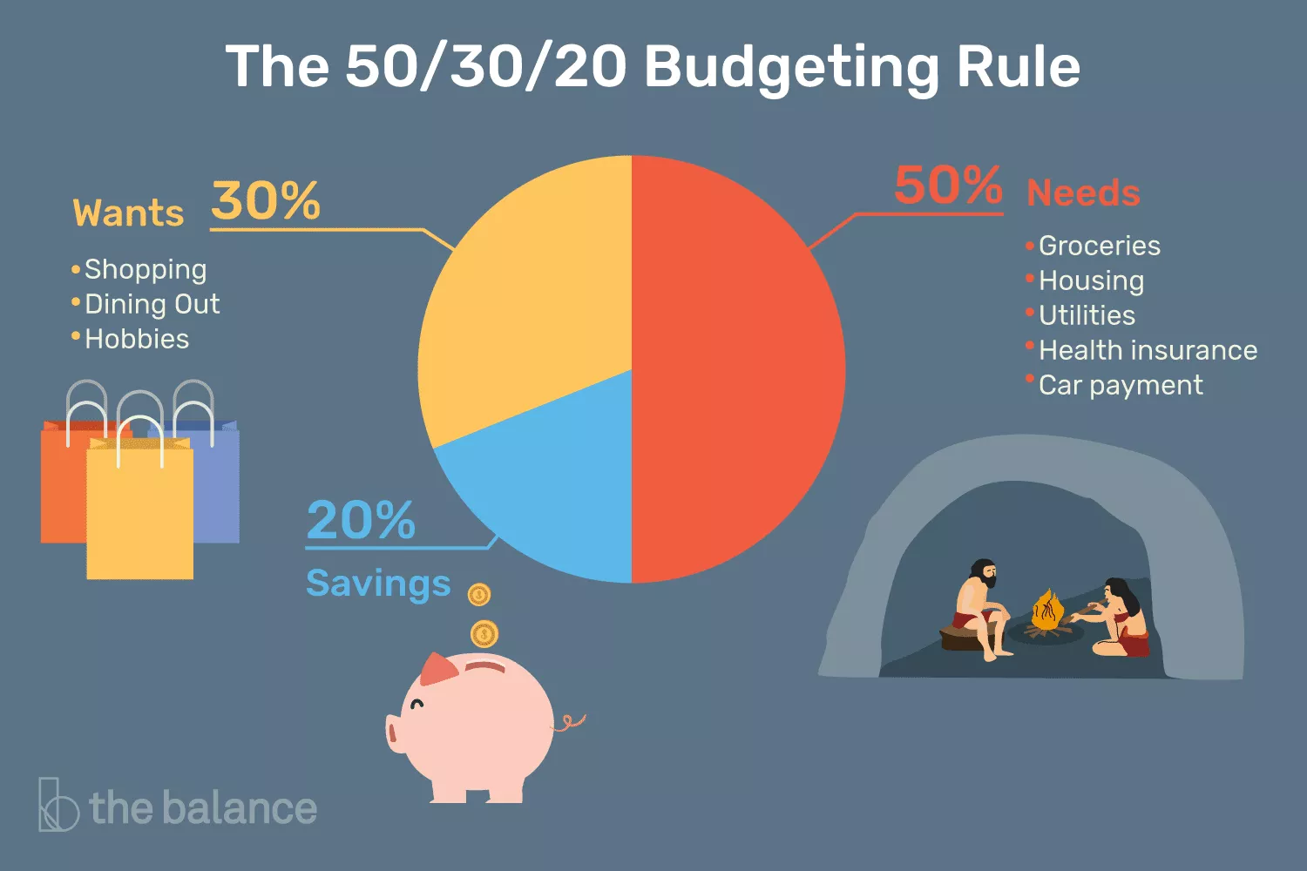

With all of these expenses in my mind, many people came up with many different budget planning to help manage their finance and the most common budget plan that many people know about is the 50/30/20 rule, popularized by Senator Elizabeth Warren in her book *“*All Your Worth: The Ultimate Lifetime Money Plan”. According to this plan, you should use 50% of your expense to your needs, 30% to your wants and 20% to your saving / debt repayment. And because of its popularity and its ease to follow, this is the plan that a lot of people used when it comes to personal finance. And they point out that the need and the want are the hardest to differentiate from, and this is where your personal finance could fail. Expense tracker will help you set the limit for each category and see what is in each category to make it easy to see what you are spending the most on.

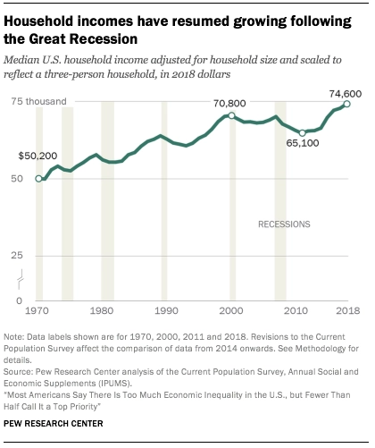

Nowadays, as the internet growing and the world changing, the people are making more money than ever before. According to (JULIANA MENASCE HOROWITZ, 2020), the median income increased by 41%, to $70,800, at an annual average rate of 1.2% in the last three decade in the US which make their monthly income about 5900 dollar and in Vietnam, the average salary increase is 6% according to (Salary Explorer, 2021) with the average 17,200,000 VND (~ 748.2 dollar as of 19/02/2021).And as they have more money to spend, they are spending money more recklessly on what they want and many companies notices this so they started putting more advertises on those platform, especially e-commerce company like Amazon and E-Bay or in Viet Nam, Shoppe, Lazada and Tiki ,tempting you with deals and sales for special occasions. For example, according to (CNBC, 2020), “Independent businesses selling on Amazon surpassed $4.8 billion in worldwide sales from Black Friday through Cyber Monday, Amazon said, noting that the figure was up 60% from last year. It added that 71,000 small and medium-sized businesses had seen sales above $100,000 in this holiday season”. And in Vietnam, according to (Vietnambiz, 2020), despite the Covid-19 pandemic, Shopee’s total sales in the first quarter of 2020 reached 314 million dollars, which is a 111% increase from 149 million dollars.

Social media is one of the main factor that made a lot of ecommerce store successful. According to (Samadrita Bhattacharyyaa, 2020), on Facebook, a social networking site, the number of likes influence customers' purchases and recommendations on a linked e-commerce site. Facebook-driven social commerce benefits from a high volume of likes but it needs to be high to impact social commerce. Social media is a perfect platform to marketers to promote their products and sales. Not only that, people feel the social pressure when they see people show off or, like a lot of people on the internet said it, ‘flexing” their wealth on social media, causing other to spend large amount of money to not get overshadowed. And because of that, their wanting become necessity to them and the spending become more uncontrollable.

And because of all the reasons mentioned above, expense tracker application is becoming more essential for young adults, who trying to learn to manage their spending such as myself. Nowadays, there are many different expense tracker applications on various platforms like Android, IOS, Windows, ... and they either come as a stand-alone app or a web-based app. The earliest apps of this kind are released in the 90s and early 2000s on Windows and Mac with the oldest one Quicken, released in 1983, and other in the 90s such as MoneyDance in 1997 and GnuCash in 1998.A typical personal finance app usually has 2 main features: tracking spending, budgeting. With the rise of mobile app, many apps added mobile support and more personal finance apps are released with more extra features other than basic features from a personal finance app such as financial advisor, investment advisor and bill-pay features. Some of the popular apps currently are “You Need a Budget”, “Mint” and “PocketGuard”. These will be the app that I will take a look at for the requirement analysis.

## 2.2 Review of development tools

In this section, I will talk about what development tools that I will use to develop my personal finance app. Since my app will be a web-based application, I will talk about my choice of front-end tools and back-end tools.

### Front-end tools

For the tools I will use to develop the front-end of the website, I will be using a mix of HTML, CSS and Bootstrap, a CSS and JavaScript Framework. So the choice of HTML and CSS is obvious because it is the core markup language to create the web interface but I also choose to use Bootstrap as well.

The main reason is because I have limited experience as a front-end developer so I wanted to find a way to create good-looking, responsive interface without spending too much time on it. Also if it works on mobile as well, it will get more appeal to the users as they can use it on both their computer and their phone. Because of that, I found Bootstrap to be suitable for this purpose. Not only it is easy to learn, but it also makes the interface responsive and mobile-first styles help the website look great on mobile.

### Back-end tools

For the back-end of the website, I need to run a database and the script to make interaction between the website and the database. First I will need to choose the database to store data, specifically the user information and their bills. Up until this point, I have experience using MySQL database and PostgreSQL database so I will have to choose one between the two of them to use in this project. After considering the pros and cons of both database, I decided to choose PostgreSQL because although the performance of both database is similar, PostgreSQL is known for protecting data integrity at the transaction level, make it less vulnerable to data corruption and secondly because of my choice of back-end programming language. My choice of back-end programming language, Python on Django framework, is frequently used with PostgreSQL for Python-based app because the developer of Django used PostgreSQL so the drivers and example code of using PostgreSQL is better documented and have fewer bugs, making it easy for me to refer and work with. And speaking about Django, it is a high level web framework that enables rapid development of secure and maintainable websites Django takes care of much of the hassle of web development, so you can focus on writing your app without needing to reinvent the wheel. (MDNWebDocs, 2020) It is also very secured with protection from many vulnerabilities and maintainable by using the Don’t Repeat Yourself principle, reducing the amount of code. With those advantages, I am hoping that this framework will help me reduce the time needed to develop the backend of the website.

## 2.3 Review of methodologies

In this section, I will talk about what methodology I will use to develop the application. System development life cycle methodologies are the industry-standard approaches of managing phases in the development life cycle. The choice of development methodology will affect the process of the development and the quality of the project at the end of development.

In the end, I chose waterfall model to avoid confusion during the development process. The waterfall model is a linear, straight-forward model for any development team to follow, especially for a one-man team such as myself. I have looked over every methodology and I feel if I choose any other methodology, it will further complex the process of development and prolong the duration. I will also try to use some other techniques in other methodology, such as bringing the most recent draft of documentation and working deliverables to my mentor for review.

# 3 Requirement analysis

In this section, I will look through some of the apps that are similar to the one that I will developing. After scouting through the internet’s articles and app stores, I choose 3 apps that is similar to what I imagine the project will look like and function. Those are “You Need a Budget”, “Mint” and “PocketGuard”, I will take a closer look at these apps and determine what features that all these apps have in common and what I need to implement into my app.

## First app: “You Need a Budget” (YNAB)

Let’s start by taking a look at “You Need a Budget” (YNAB). The app was started by a CPA named Jesse Mecham to help him and his wife, Julie, deal with real-life financial struggles. The app offers not only the mechanics of monitoring income and expenses, but also provides instructional advice to help you deal with the root causes of financial distress with a 34 day free-trial and after that is 11$ per month. It is available on Windows through web, Android and IOS.

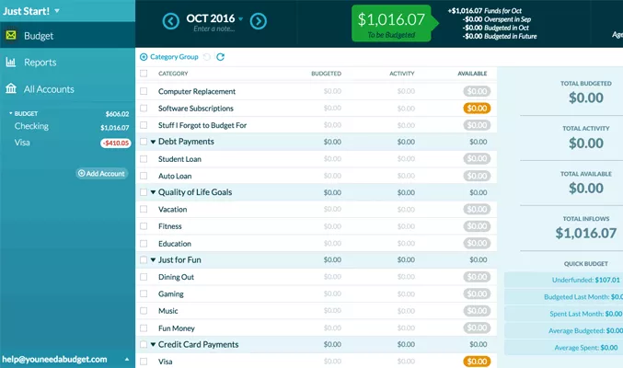

When the user enters a brand new budget, they have to enter the category and the money they budgeted for that category and they can adjust it when they spend under or over that estimated budget. Each category is in a specific section such as true expense, immediate obligation and debt payment and you can add, remove or rename your category as much as you want. After you are done setting up your budget, you will see the total cash flow for the month on the top bar. Along with it are the total of the budget for the month, total monthly activity and total available budget and the total left that is yet to be allocated. Once you have more money to budget for the month than you need to cover your expenses, you’ll see the top bubble turn green and orange if the opposite happens. On the right corner, you can see the age of money, it is any money that hasn’t been in your account for at least 30 days. The longer, the better. Once you can reach this point, the idea is you will be consistently living off of last month’s money, creating a small emergency fund in your checking account every month.

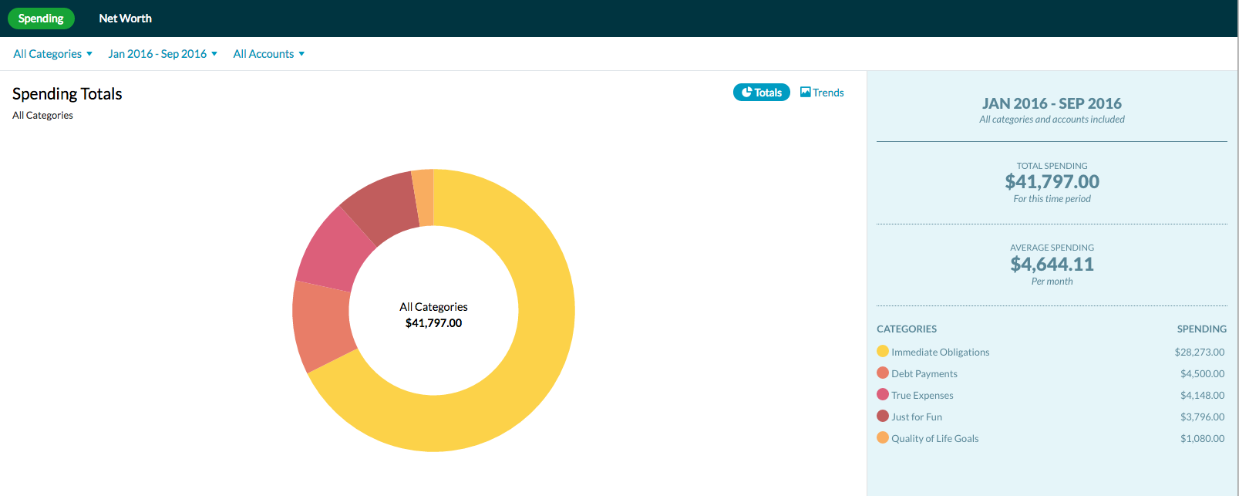

When you go to report, you will see your budget in the form of chart and you can see your budget in more detail or if you want to see the breakdown of a specific category, you can click on it to see more details.

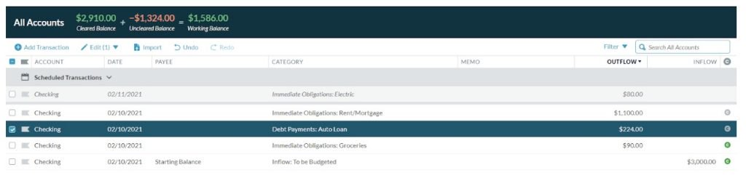

Finally, you can link your bank account to import transactions to help you in logging your transaction.

After all, I have complied a list of features of YNAB:

* Budgeting
* Investment tracking
* Bill management
* Goals setting
* Customizable categories
* Generate charts from account budget
* Online synchronization
* Two-Factor Authentication

## Second app:”Mint”

Next up is “Mint”. Mint, also known as Intuit Mint, is a simple and free personal finance web-based application produced by Intuit. It makes budgeting and expense tracking payment easy. It is available on Window through web-based, Android and IOS.

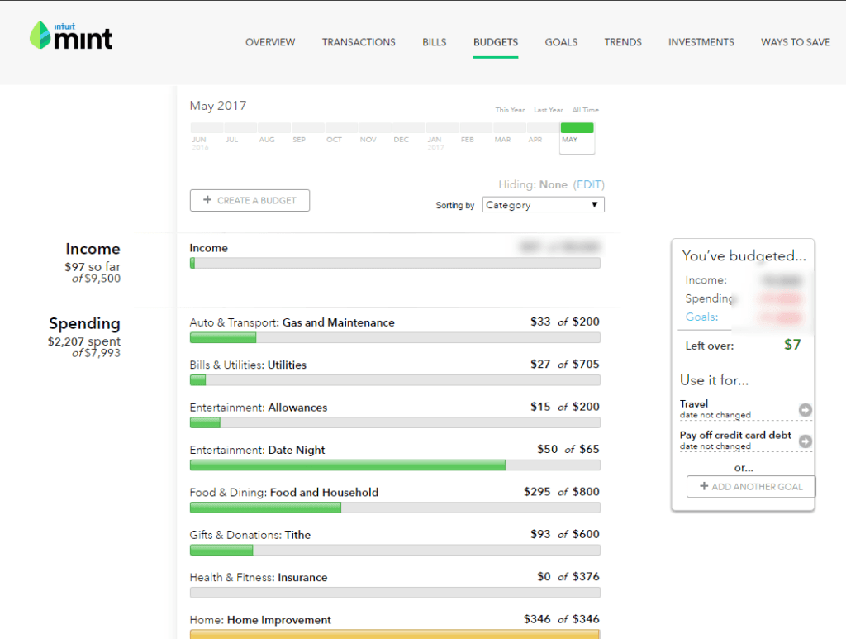

The main features of Mint are budgeting and expense tracking. It requires you to link your bank account to sync with the app and after that, your transaction will be automatically put in a pre-defined category, you can only create and modify subcategories but not the pre-defined ones. You still have the options of changing your transaction after being synced.

Another prominent feature is setting and managing goals. You can easily set up new goals such as paying off student loans or saving for a vacation and are reflected in your monthly budgeting.

Trends is a helpful tab that helps you see your spending data over the time You can look at a breakdown of your spending by merchant, by category, or by tag. Or you can look at how your income has changed over time.

The investment tab keeps a tab on where your investment and their value over time. You can hook up your investing account and make some investing recommendations as well.

“Ways to save” tab is one of the ways this free app uses to make money, it lets you check on offers and deal on credit card, insurance, etc... as a form of advertisement.

And finally, the billing tab is used to keep track of due bills in the month, your available cash in your account and credit. It can also give you a timeline of when your bills are due, including the amount due.

Here is a compiled list of features of Mint:

* Budgeting
* Investment tracking
* Bill management
* Goals setting
* Tax reporting
* Customizable categories
* Online synchronization
* Finding offer for you
* Two-Factor Authentication

## Third app: “PocketGuard”

And finally, it’s “PocketGuard”. It’s a personal finance information service that helps you track your spending, create budget and lower expenses. It’s also able to monitor unwanted and unauthorized charges. It has a free version called “PocketGuard Basic” and a paid version “PocketGuard Plus”, both are available on Android and IOS, with a beta-testing web app on Windows.

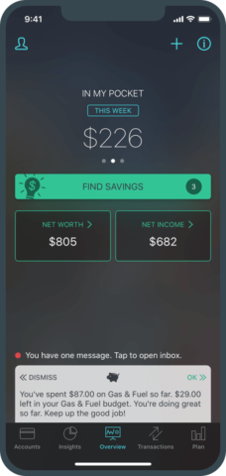

This is the “In My Pocket” feature which tell how much money you have left after analyzing your income, bills, saving goals and spending.

“PocketGuard” allows you to link your accounts to the app and it will automatically pull all your transactions and categorize it. If the category it put your transactions is wrong, you can fix it yourself.

You can take categories a step further by making hashtags to add another layer of organization such as putting all transactions that related to a specific vacation trip in #vacation.

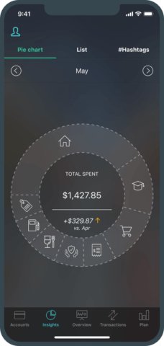

The app takes all of your spending and display it in pie chart form, making it easy to see how much you spent in each category.

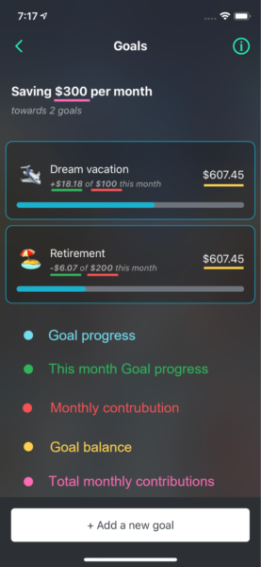

You can set up saving goals or payoff goals, which the app can also provide some recommendations, and set up different spending limit for different spending category, which the app will notify when you are about to hit it. You can also find the “Find saving” tab which is a list of other financial service apps that help you lower your expense, get rebate for shopping, etc... It’s the same way that “Mint” used to make money out of free app.

In the paid version of “PocketGuard”, there are more features that you can make use of and have more freedom in other features as well. For transactions feature, you can change the date of the transaction, manually add transaction that was made in cash, manage ATM withdrawals and deposits and you can export your spending data into an Excel or Google sheets. You can also set unlimited saving goals instead of one in the free version.

Here is the complete list of features in both versions of “PocketGuard”:

* Budgeting
* Investment tracking
* Bill management
* Goals setting
* Customizable categories
* Generate charts from account budget
* Online synchronization
* Finding offer for you